Jake Traut

CSCI 4446 Problem Set 5

1. Adaptive RK4
2. 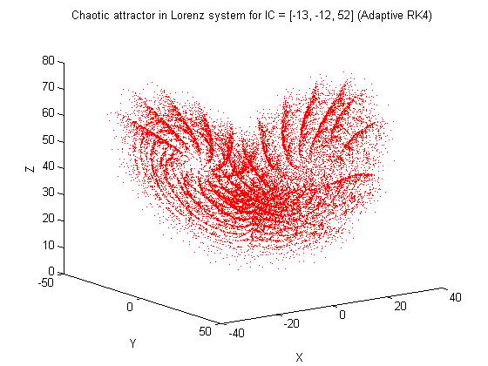Plotting
   1. 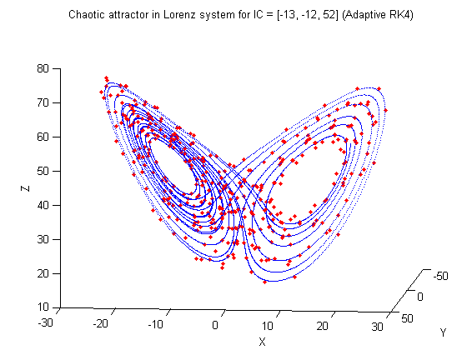 A

Plotting the adaptive RK4 (in red) over the set time step RK4 shows that the two solutions agree. The red dots of the adaptive RK4 follow the same path as the non-adaptive blue trajectory, but as you can tell it is much more jagged compared to the smooth non-adaptive path. This comes as no surprise as the non-adaptive RK4 solver is using a consistently small time step such that it’s points stay within close proximity throughout, making for a tight curve, while the adaptive version allows for its time step to grow along paths that don’t change as rapidly such that its points become more spread. These non-evenly spaced points over time are the motivation behind using an adaptive solver, as it produces the same overall trajectory but with much less computation.

* 1. Changing the r parameter of the Lorenz system creates major changes in the behavior of the chaotic attractor. For values of r between 0 and 1, the system remains fairly sparse in its projection following a single standout path that converges to a single fixed point. Referencing the plot as well as the data printed to the results file shows that this point is the origin. If r is set to 1 you will actually see a bifurcation to two stable fixed points. With values of r between 13.5 and 14 the system alters between the two attractors of the system, the lower of this range spiraling into one fixed point and the upper bound of this range to the other attractor. As r grows between 23 and 29 the spiral trajectory along the basin of attraction becomes much denser and when r is beyond 29 the overall chaotic attractor of the system (the two separate spirals) is brought to life.

1. 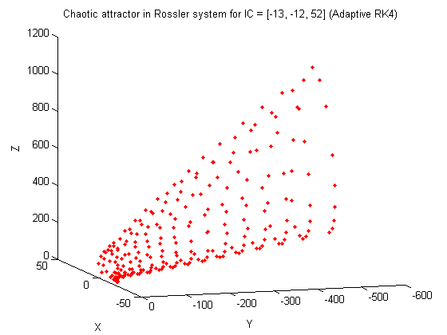Rossler System

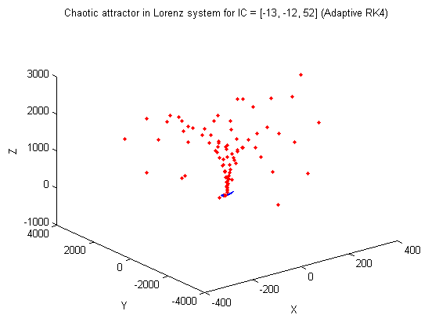

This plot demonstrates the dynamical break down that occurs when the error tolerance reaches 4.328, and anything beyond this becomes so blown out of proportion that the values reach too large for the computer to store and you can only see two points in the plot with extremely large values. This relates to how a significant change in the time step can “break down” the system that steps too far from the true system to regain its bearings and rather goes off in a new trajectory away from the attractors. The high error tolerance does precisely so in allowing the time step to grow too large without care of correction.